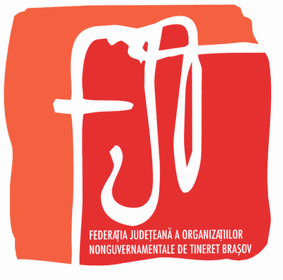



B-dul M. Kogalniceanu 19C, C35, Et. 8, Ap. 1, 500173 Brasov
Telefon/Fax : 0268-313026
e-mail: fjt@rdsbv.ro http://fjt-bv.tripod.com

JOY ART Festival

A festival: music, theatre, stand up comedy and of course youth creating art, in action for all of us.
Braşov County's Federation of Youth NGO organizes in 17-18 of November 2005, in Braşov, music, theatre and film event „JOY ART Festival”.

SECTIONS
Music, theatre, film

OBJECTIVES
- Promoting young talents and their creations
- To stimulate artistic creativity of youth
- Experience exchange between youth
- Getting in contact of young artists with producers
CONDITIONS OF PARTICIPATION
The festival is open to amateur artists with age between 18-25.
Participants will ensure by themselves accommodation and meals; the organizers will propose accommodation offers with low costs. For reservations please contact us.
REGISTRATION: Free

REGISTRATION FILE
Registration file for reselections will contain:
- a written form – http://fjt-bv.tripod.com/noutati.html
- a C.V.
- for music section: an mp3 demo
- for theatre section: a CV with a short presentation of the play
- for film section: online material on ftp server so that the organizers can download it; in case you will be selected we will demand the material in avi (divx codec) or mpeg (mpg1 or mpg2) format
Will be selected – for:
- music: 10 interpreters/band
- stand up comedy: 10 interpreters
- theatre: 7 troupes
- film: 7 calipers

The nominees will be informed about the results selection through e-mail.
The registration files won’t be returned, but the organizers assume their responsibility not to publish them. Any incomplete file or sent after the deadline won’t be received.

The registration files can be sent through:
e-mail:
fjtbrasov@gmail.com
Subject: JOY ART Festival

DATE
Deadline: October 30, 2005
Organizer’s answer: until November 10, 2005

DETAILS
MUSIC Section
Two songs: an original creation and a cover
- Songs will be performed live with negative on audio cd
- One song can last maximum: 4 minutes
THEATRE Section
Sketch „stand up comedy”, monologs, jokes
- Maximum length: 10 minutes
Humoristic play
- Maximum length: 20 minutes

FILM Section
Short reel or clips (own production)
- Maximum length: 10 minutes

CONTACT

Office telephone: 0268 313026
E-mail: fjtbrasov@gmail.com
Codruta Mihalcea codruta.mihalcea@gmail.com

